**Student ID: 17272381**

**Name: Zhihan Wang**

**Site title:** Javascript Tutorial

**Development roles :**myself**.**

**Need**: Nowadays almost all web pages contain JavaScript, a scripting programming language that runs on visitor's web browser. It makes web pages functional for specific purposes. Learning Javascript is a great starting point for computer programmer to start their career.

**Rationale or focus:** A neat and simple handbook for beginner of programmer to look up basic javascript programming concept. I am also aiming for learning and practicing the usage of HTML5 , CSS and JS through working on this assignment.

**Main elements outline:**

Web structure has been used for this project, the relation is as below image. All the sections can be navigated each other. <header> shows the title of each page and horizontal <nav> to the next page, <section> contains content , code demonstrations, practice tasks, and feedback form. Side <nav> shows link to other pages. <aside> is the place to advertisement and donation spots to let the website supported by fans and audiences.

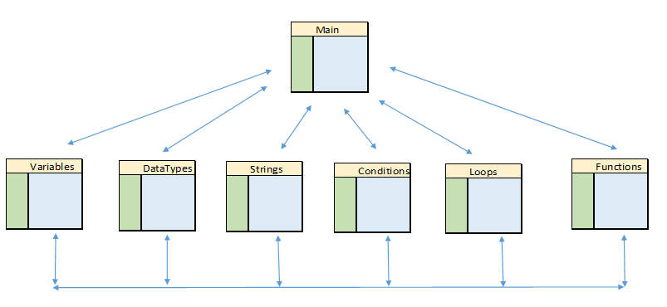

**Content:** the website has sections : an introduction of JavaScript history , usage of Variables, datatypes, Loops, Conditions, Strings and Functions.

**Target audience:**  Beginner of computer science and software engineering students/ programmers .

**Design considerations:** In each section , there is a basic code example demonstration, a couple of practice tasks below to reinforce learner’s knowledge and a feedback form to interact with visitors for further enquiries. Advertisement and donations are vital for continuous development of website.

**Limiting factors:** hard coding of HTML5 elements and CSS style sheet , to write js code , test and debug code for this project has consumed me a lot of time.

Due to insufficient human resources and time , it is difficult to implement and explore additional fancy functions , which could be normally viewed from popular websites such as Youtube , Facebook etc.

Accessibility manual has been consulted , however, it is difficult to implement for color blind audiences since it would affect the reading for majority of people. Color Blind mode would be a good idea to serve such audiences, but there is no time for me to implement this idea.